# **Name: Abdurrahman Qureshi**

# **Roll No: 242466**

Practical No: 8

Q) Write a shell script to perform arithmetic operations.

CODE:

echo "Enter two numbers (separated by a white space):"

read x y

echo "Addition: $(($x + $y))"

echo "Subtraction: $(($x - $y))"

echo "Multiplication: $(($x * $y))"

echo "Division: $(($x / $y))"

echo "Modulus: $(($x % $y))"

OUTPUT:

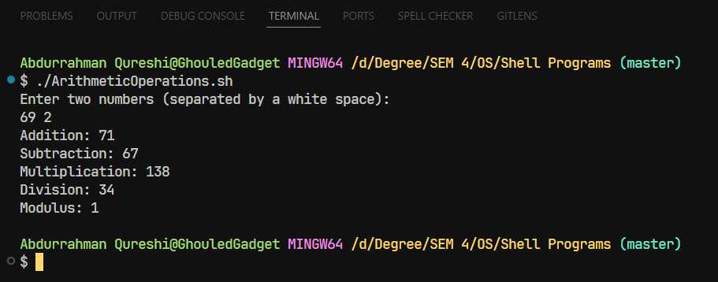

Q) Write a shell script to calculate simple interest.

CODE:

echo "Enter principal amount:"

read principal

echo "Enter rate of interest:"

read rate

echo "Enter time (in years):"

read time

interest=$(( (principal * rate * time) / 100 ))

echo "Simple Interest: $interest"

OUTPUT:

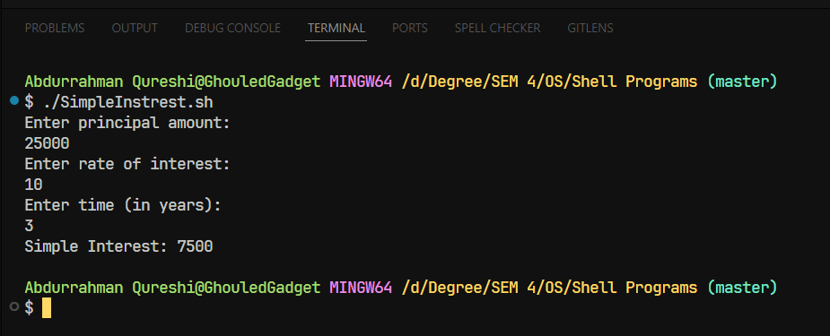

Q) Write a shell script to determine largest among three integer numbers.

CODE:

echo "Enter three numbers (separated by white spaces):"

read x y z

if [ $x -gt $y ] && [ $x -gt $z ]; then

    echo "$x is the largest."

elif [ $y -gt $x ] && [ $y -gt $z ]; then

    echo "$y is the largest."

else

    echo "$z is the largest."

fi

OUTPUT:

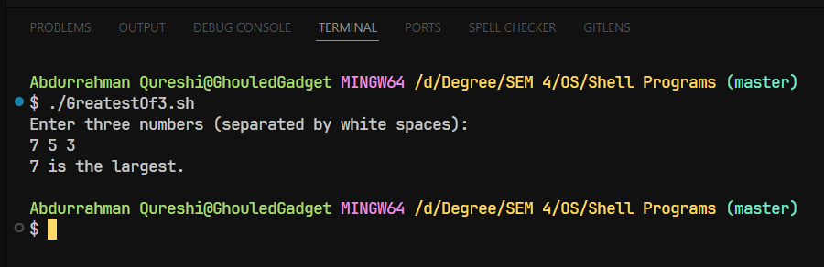

Q) Write a shell script to determine a given year is leap year or not.

CODE:

echo "Enter a year:"

read year

if [ $((year % 4)) -eq 0 ] && [ $((year % 100)) -ne 0 ] || [ $((year % 400)) -eq 0 ]; then

    echo "$year is a leap year."

else

    echo "$year is not a leap year."

fi

OUTPUT:

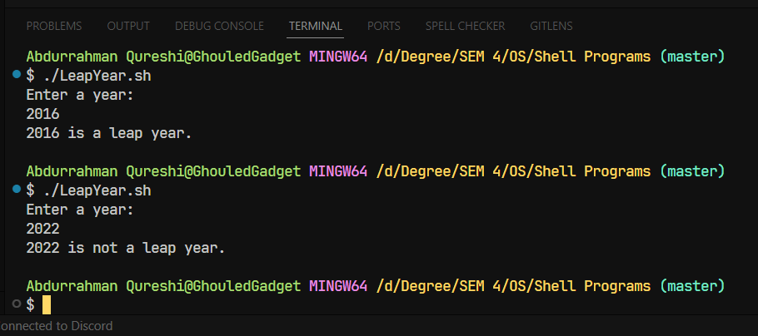

Q) Write a shell script to print multiplication table of given number using while statement.

CODE:

echo "Enter a number:"

read x

i=1

while [ $i -le 10 ]; do

    echo "$x * $i = $((x * i))"

    i=$((i + 1))

done

OUTPUT:

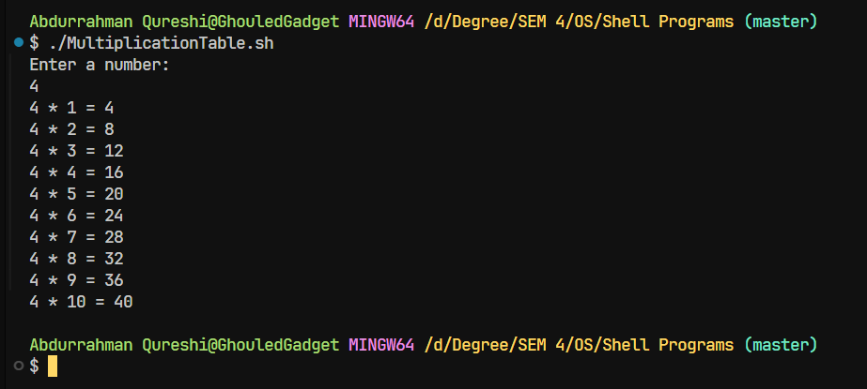

Q) Write a shell script to search whether element is present is in the list or not.

CODE:

echo "Enter elements of the list (separated by spaces):"

read -a list

echo "Enter the element to search:"

read element

found=0

for item in "${list[@]}"; do

    if [ $item -eq $element ]; then

        found=1

        break

    fi

done

if [ $found -eq 1 ]; then

    echo "$element is present in the list."

else

    echo "$element is not present in the list."

fi

OUTPUT:

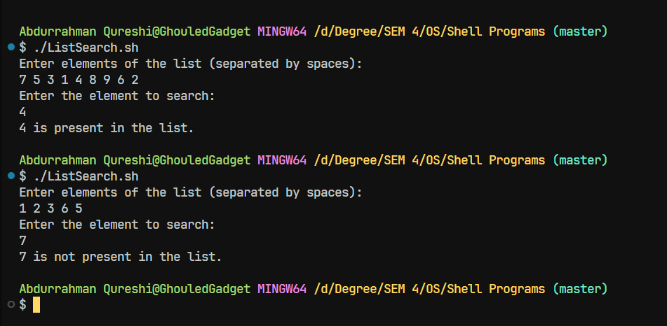

Q) Write a shell script to compare two strings.

CODE:

echo "Enter first string:"

read s1

echo "Enter second string:"

read s2

if [ "$s1" == "$s2" ]; then

    echo "Strings are equal."

else

    echo "Strings are not equal."

fi

OUTPUT:

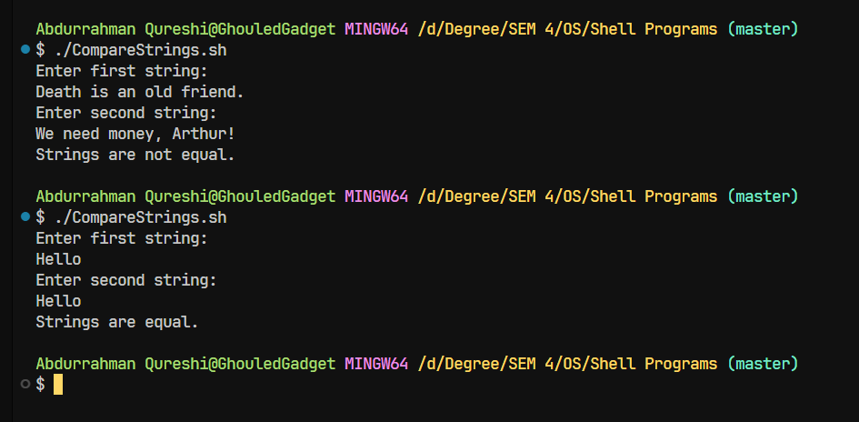

Q) Write a shell script to read and check if the directory / file exists or not, if not make the directory / file.

CODE:

echo "Enter the directory/file name:"

read name

if [ -e "$name" ]; then

    echo "$name exists."

else

    echo "$name does not exist. Creating it..."

    mkdir -p "$name"

fi

OUTPUT:

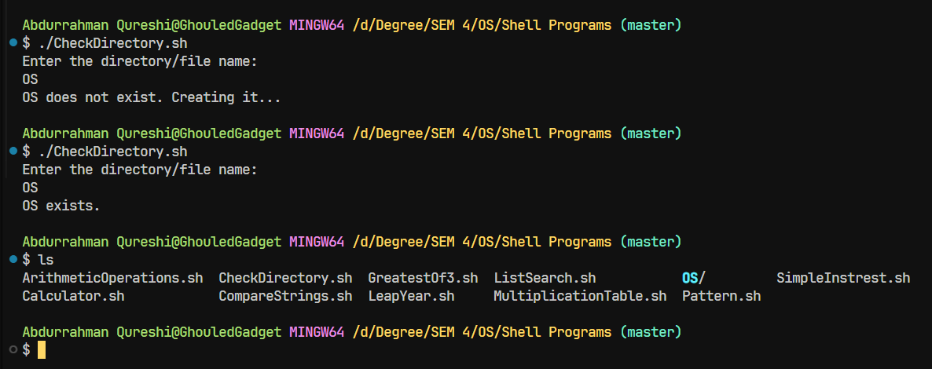

Q) Write a shell script to implement menu-driven calculator using case statement.

CODE:

echo "Select Mode:"

echo "1. Addition"

echo "2. Subtraction"

echo "3. Product"

echo "4. Division"

read choice

echo "Enter two numbers:"

read x y

case $choice in

    1) echo "Addition: $(($x + $y))" ;;

    2) echo "Subtraction: $(($x - $y))" ;;

    3) echo "Product: $(($x * $y))" ;;

    4) echo "Division: $(($x / $y))" ;;

    *) echo "I do not know this, sorry" ;;

esac

OUTPUT:

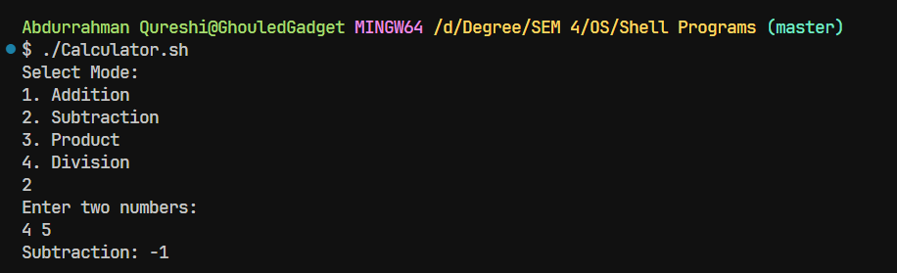

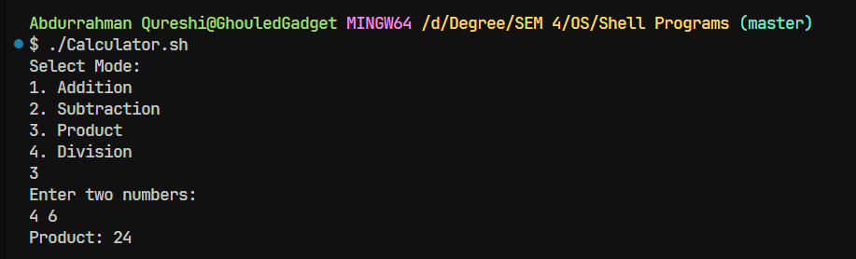

Q) Write a shell script to print following pattern

*

* *

* * *

* * * *

CODE:

echo "Enter number of rows:"

read rows

for ((i=1; i<=rows; i++)); do

    for ((j=1; j<=i; j++)); do

        echo -n "* "

    done

    echo

done

OUTPUT:

